Next Year in Havana
by Chanel Cleeton

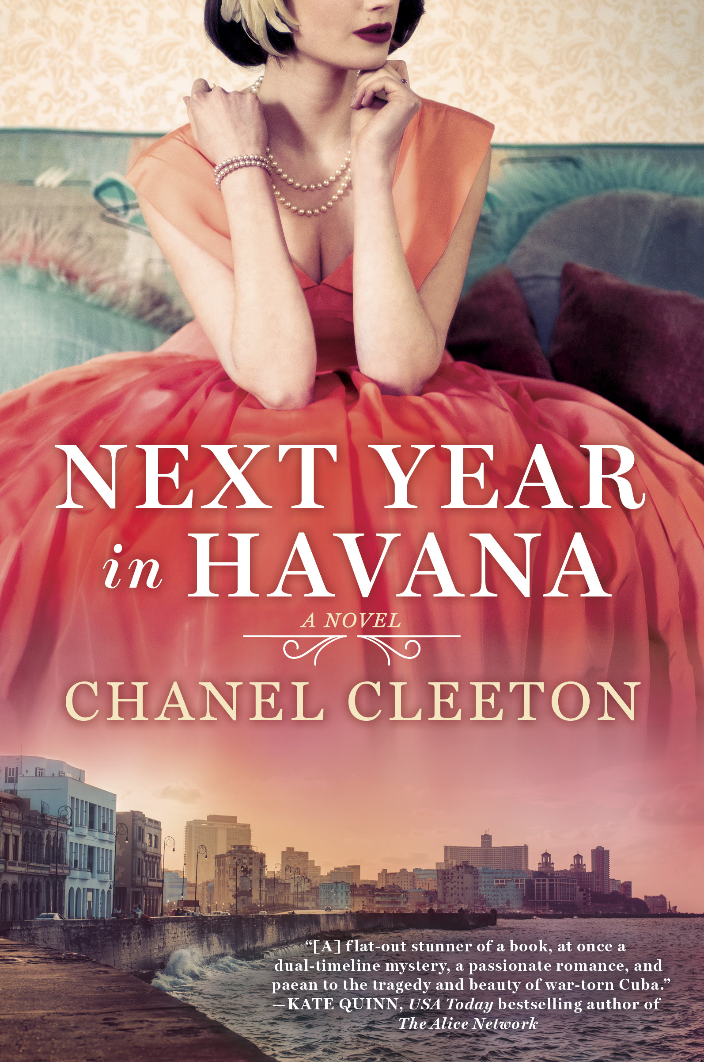

February 6, 2018
Women’s Fiction/Historical Fiction
Penguin/Berkley

Book Summary:

After the death of her beloved grandmother, a Cuban-American woman travels to Havana, where she discovers the roots of her identity--and unearths a family secret hidden since the revolution...
Havana, 1958. The daughter of a sugar baron, nineteen-year-old Elisa Perez is part of Cuba's high society, where she is largely sheltered from the country's growing political unrest--until she embarks on a clandestine affair with a passionate revolutionary...
Miami, 2017. Freelance writer Marisol Ferrera grew up hearing romantic stories of Cuba from her late grandmother Elisa, who was forced to flee with her family during the revolution. Elisa's last wish was for Marisol to scatter her ashes in the country of her birth.
Arriving in Havana, Marisol comes face-to-face with the contrast of Cuba's tropical, timeless beauty and its perilous political climate. When more family history comes to light and Marisol finds herself attracted to a man with secrets of his own, she'll need the lessons of her grandmother's past to help her understand the true meaning of courage.

Book Links:

Amazon: http://amzn.to/2pdQBKF
Barnes & Noble: http://bit.ly/2pYsJJY
iBooks: http://apple.co/2pvYffq
IndieBound: http://bit.ly/2zrt11m
Kobo: http://bit.ly/2wPZPMU
Goodreads: https://www.goodreads.com/book/show/34374628-next-year-in-havana
Learn more about Next Year in Havana including downloading the book club guide and more at: http://www.chanelcleeton.com/next-year-in-havana/

Add Beatriz Perez’s story WHEN WE LEFT CUBA on Goodreads: https://www.goodreads.com/book/show/38193131-when-we-left-cuba

Praise for Next Year in Havana:

Chanel Cleeton's Next Year In Havana is a flat-out stunner of a book, at once a dual-timeline mystery, a passionate romance, and paean to the tragedy and beauty of war-torn Cuba. The story of sugar heiress Elisa, watching Cuba fall into revolution as Castro rises, is intertwined with the modern-day tale of Elisa's granddaughter Marisol as she returns to Cuba after Castro's death. Both women fall for fire-brand revolutionaries, but Cuba itself emerges as their true love-interest, threatening to break both women's hearts as Elisa and Marisol each grapple in their own way with what it is to be Cuban, what it is to be an exile, and how to love and live in a homeland riven by revolution. Simply wonderful!
- Kate Quinn, New York Times bestselling author of The Alice Network
Cleeton has penned an atmospheric, politically insightful, and highly hopeful homage to a lost world. Devour NEXT YEAR IN HAVANA and you, too, will smell the perfumed groves, taste the ropa vieja, and feel the sun on your face. Just a wonderful and educational book!
- Stephanie Dray, New York Times bestselling author of America's First Daughter
A vivid, transporting novel. Next Year in Havana is about journeys-- into exile, into history, and into questions of home and identity. It's an engrossing read.

- David Ebershoff, author of The Danish Girl and The 19th Wife
An evocative, passionate story of family loyalty and forbidden love that moves seamlessly between the past and present of Cuba’s turbulent history— how one young woman’s sacrifice becomes the key to her granddaughter’s future—how culture and spirit survive against all odds. Next Year in Havana kept me enthralled and savoring every word.
- Shelley Noble, New York Times bestselling author of Whisper Beach
In Next Year in Havana, Chanel Cleeton's prose is as beautiful as Cuba itself, and the story she weaves--of exile and loss, memory and myth, forbidden love and enduring friendship--is at once sweeping and beautifully intimate. This is a moving, heartfelt, and gorgeously realized story that will stay with you long after you turn the final page.
- Jennifer Robson, USA Today bestselling author of Somewhere in France

Author Information:

Originally from Florida, Chanel Cleeton grew up on stories of her family's exodus from Cuba following the events of the Cuban Revolution. Her passion for politics and history continued during her years spent studying in England where she earned a bachelor's degree in International Relations from Richmond, The American International University in London and a master's degree in Global Politics from the London School of Economics & Political Science. Chanel also received her Juris Doctor from the University of South Carolina School of Law. She loves to travel and has lived in the Caribbean, Europe, and Asia.

Author Links:

Website: www.chanelcleeton.com
Facebook: www.facebook.com/authorchanelcleeton
Facebook Reader Group: https://www.facebook.com/groups/1545366192398558/
Twitter: www.twitter.com/chanelcleeton
Goodreads: www.goodreads.com/chanelcleeton
Newsletter: www.chanelcleeton.com/mailing-list/
Instagram: www.instagram.com/chanelcleeton/

